Forslag til kursusdage 2024
4 x 2 timer + evt. en dag til brænding .. afhængig af vejret
Maj Tirsdag 9. – Fredag 12. Danmark
Juni Tirsdag 6. – Fredag 9. Sverige
August Tirsdag 15. – Fredag 18. Danmark
September Tirsdag 17. – Fredag 20. Sverige
“How to make your own black pots”
(Various types), history, tools and working techniques
Price
Each participant 750 DKK+materials
Form a group (2 - 5) to get a course – then we’ll find out date and place
Duration 4 days with 2 hours a day
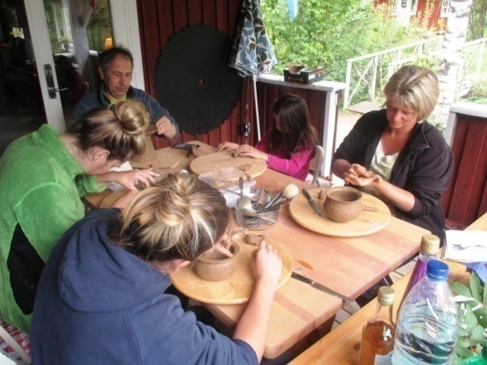 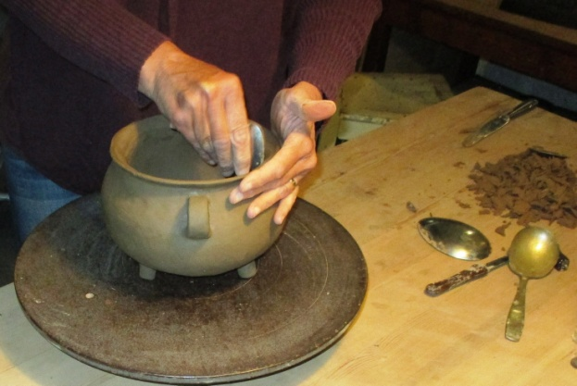
Adress
Knudsgaard, Knudsgaard, Tim Kirkevej 30, 6980 Tim, Danmark
Or: Sjöbo, Lille Gräsken, Gräskelid 3, 514 94 Sjötofta, Sverige GPS N 57.312482 E 13.305968
Contact: E-mail oleflemming@yahoo.dk Skype: oleflemming1
Facebook ole flemming nielsen: https://www.facebook.com/groups/1727516080818265/
INSTRUCTOR: Ole Flemming Nielsen-Primary school teacher – now retired. Potter through 40 years. If you want to, you can hire Sjöbo during the week the course runs https://www.stugnet.se/objekt.asp?id=20472
Materials:
Knives, spoons, junipersticks 10 DKK/ each, Fine sifted sand15 DKK/kg
Clay 7.50 DKK/Kg clay mixed with sand 15 DKK/kg
Skills
It is not necessary to have experience with clay.
You will have time to make 2-3pots.
(Course of 4 days does not give time for pots larger than about 4 liters)
Firing
Firing one's ownpots cannot be done at the course,
they must dry very slowly(at least 10 days)You can do it at home or make an appointment,
then I’ll fire your pots later. (Price about 50 DKK/pot depending on size)

